Weathering the Storm: A Literature Synthesis on the Impact of Structural Racism, Anticipatory Trauma, and Socioeconomic Deprivation on Black Maternal Well Being (2020 – 2025)

Lucy Onyinye Efobi¹ & Kamilah Marie Woodson²
1. Nursing BSN, Felician University, Parsippany, N.J
2. Professor, Ph.D., Howard University, Washington, D.C

Abstract
Introduction: Black women in the United States experience disproportionately high rates of maternal and infant mortality, reflecting persistent racial inequities in healthcare.
Problem Statement: The primary objective of this literature synthesis was to explore how pregnant Black women experience and interpret psychosocial stressors that contribute to elevated allostatic load, defined as the cumulative “wear and tear” on the body and brain due to chronic exposure. This includes sociocultural identity stressors, healthcare discrimination, systemic inequities, and anticipatory trauma in adverse maternal health outcomes.
Methods: A literature synthesis was conducted using PRISMA guidelines across PubMed, Google Scholar, EBSCO, SpringerLink, and ProQuest databases. Six peer-reviewed studies published between 2020 - 2025 met inclusion criteria and were critically appraised using the Joanna Briggs Institute (JBI) and ConQual tool.
Results: Findings revealed three major themes: police and healthcare violence, interpersonal violence, and the psychological burden of survival. Participants described chronic exposure to racism, unsafe neighborhoods, intimate partner violence, financial instability, lack of social support, and dismissal by healthcare providers, contributing to chronic stress and increased allostatic load. Additional stressors included internalized racism, stereotype pressure, hair texture bias, and the “Strong Black Woman” expectation, which often normalized pain endurance and delay care/diagnosis.
Conclusion: Black maternal health disparities are deeply rooted in structural and psychosocial inequities that extend beyond biomedical risk factors. Healthcare organization policy and practice should address black maternal care interventions that are accessible, cost effective, and community centered to combat elevated allostatic load and adverse health outcomes.

Keywords: black maternal health, maternal health disparities, pregnancy, allostatic load, strong black women schema, weathering hypothesis, social determinants of health, structural racism, police violence, chronic stress, maternal health outcomes

Positionality
We approach this work from our distinct, yet interconnected positionalities shaped by our educational backgrounds, professional training, and lived experiences. Lucy Onyinye Efobi, a fourth-year undergraduate at Felician University majoring in Nursing, approaches public health with a clinical and patient centered perspective. Her hands-on experience as a student nurse in various health care settings has strengthened her understanding of the structural barriers that impact health outcomes. These experiences inform her commitment to delivering equitable, compassionate, and culturally competent care for underserved communities. Kamilah Marie Woodson contributes an academic and research-oriented lens grounded in critical inquiry developed at Howard University. She offers insight rooted in psychological functioning among women of color and how systemic inequities influence mental health and well-being. Together, we acknowledge how our identities, disciplines, and institutional affiliation influence how we approach this work and interpret academic journals. Therefore, we were careful not to make assumptions and biased conclusions. We strive to continuously reflect on our biases, uphold integrity, translate research into interventions, and maintain our commitment to equity and inclusion.

Introduction
Maternal mortality is a crucial measure of population health and the effectiveness of healthcare systems around the world. Unfortunate, despite advances in obstetric care, the United States continues to have alarmingly high maternal mortality rates that overwhelmingly affect Black women. In 2024, the pregnancy related maternal mortality rate in the United States was 18.6 deaths per 100,000 live births; however, that figure dramatically rises among Black women (44.8), which is three times higher than those of White (14.2), Hispanic (12.1), and Asian (18.1) women¹. These disparities also extend to infant outcomes, with Black women facing approximately 50% higher rates of preterm birth compared to White and Hispanic women², and Black infants experience mortality rates double the national average³. Research shows that non-Hispanic Black women have a higher risk for adverse birth outcomes, even after controlling for socioeconomic factors⁴. Growing evidence points to chronic stressors, including structural racism, socioeconomic instability, and environmental stressors, which play a critical role in shaping maternal health outcomes for Black women⁵⁻⁷.
Understanding psychosocial stress is vital for addressing maternal health because chronic stress can become biologically ingrained through allostatic load, which is the cumulative physiological “wear and tear” resulting from repeated activation of the body’s stress response systems, scientifically known as the hypothalamic-pituitary-adrenal (HPA) axis⁸. Persistent exposure to social, structural, and economic adversity contributes to dysregulation across multiple biological system. This is particularly concerning because pregnancy is a period characterized by heightened physiological demands, and stress exacerbates the susceptibility to adverse pregnancy outcomes.
The weathering hypothesis complements the concept of allostatic load by proposing that Black women experience accelerated physiological aging as a result of chronic stress⁹. Rather than focusing on isolated stressors, weathering reflects the cumulative burden of navigating systems of racism and inequality over the life course. This persistent state of heighten vigilance, otherwise known as “fight or flight,” contributes to biological deterioration and an increased susceptibility to chronic illness, even after pregnancy⁹.
Empirical evidence supports these theoretical frameworks. Chronic worry about racial discrimination is significantly higher for Black women and is strongly correlated with preterm birth¹⁰. Black women also experience more stressful life events than their White counterparts, which contributes to increased risk of pre-pregnancy hypertension (8.2%) and pregnancy-induced hypertension (13.6%)¹¹. Furthermore, researchers have found that lifetime perceived racism and childhood exposure to racism predicted an additional 6% of the variance in birth weight among African American women and their newborns, even with adequate prenatal care and socioeconomic status¹². The COVID-19 pandemic further magnified these existing barriers to care. During the pandemic, Black pregnant women reported inadequate communication from healthcare providers, disrupted access to supportive prenatal/postpartum care, and heightened anxiety related to medical discrimination and the pandemic itself¹³.
Moreover, the pressure to embody the Strong Black Woman or Superwoman identity can intensify stress during pregnancy^{14,15}. Historically, this identity functioned as a coping mechanism to counteract the negative characterizations of African American women in media such as the Angry Black Woman, Mammy, Jezebel, Welfare Queen, or Sassy Black Friend^{14,15}. Although the Superwoman identity highlighted positive attributes of Black Women, it encouraged emotional suppression, self-sacrifice, and the assumption of multiple caregiver and provider roles. The Strong Black Woman scheme encourages black women to endure in the face of persistent adversity without adequate opportunities for emotional expression or support^{14,15}. During pregnancy, this constant emotional labor may amplify physiological stress responses, contribute to increased allostatic load, and exacerbate disparities in maternal health outcomes.

This literature synthesis integrated allostatic load theory, “Strong Black Woman” Schema, and the weathering hypothesis to develop a conceptual understanding of how psychosocial and structural stressors act as physiological risk factors for Black pregnant women. This synthesis delves into how Black women articulate psychosocial stress during pregnancy. The following research question guided this review:
How do psychosocial stressors, including structural inequities, sociocultural identity pressures, and experiences of trauma, shape maternal health experiences among pregnant Black women?

Methods
Relevant literature was compiled through searches across major academic databases, including PubMed, Google Scholar, EBSCO, SpringerLink, and ProQuest. The articles addressed maternal health outcomes, psychosocial stressors, or structural determinants affecting Black women in the United States. Searches were conducted using combinations of keywords and phrases such as Black women, maternal health disparities, maternal mortality, psychosocial stress, racial discrimination, structural racism, intersectionality, and pregnancy outcomes. These databases were selected for their accessibility and availability of full-length and peer-reviewed articles from the university library. The Preferred Reporting Items for Systematic Reviews and Meta-Analyses (PRISMA) guidelines were used to identify relevant articles for this review¹⁶, and the PRISMA process is summarized in Figure 1. Inclusion criteria included Black women, studies published from 2020 to 2025, studies in English, studies in the United States of America, and all peer-reviewed research types were included (quantitative, qualitative, and mixed methodologies). Exclusion criteria included studies from a wider target population, studies that did not report results on maternal health disparities for Black women (e.g., women from other ethnic groups), studies published before 2020, non-English studies, studies outside of the United States, systematic reviews, and conference abstracts.
Articles were screened by their titles and abstracts, and then full texts were analyzed in-depth. Ultimately, only 6 articles met the inclusion criteria. The Joanna Briggs Institute (JBI) critical appraisal tool was used to assess the dependability of the qualitative (n = 4) and cross-sectional/mixed studies (n= 2) included in the review ¹⁷⁻¹⁸. The JBI appraisal process is a pre-requisite for literature synthesis before the ConQual approach was used to establish the overall credibility level in the synthesized evidence¹⁹. Each article was carefully evaluated to determine the level of congruence between the original study findings and the author’s interpretation. Findings were categorized as Unequivocal, Equivocal, or Unsupported. The final confidence rankings were determined by combining the results of dependability and credibility. Overall, the included studies were classified as having High, Moderate, or Low confidence, with all included articles demonstrating high dependability according to the JBI appraisal criteria.

Figure 1: PRISMA – Identification of studies via database
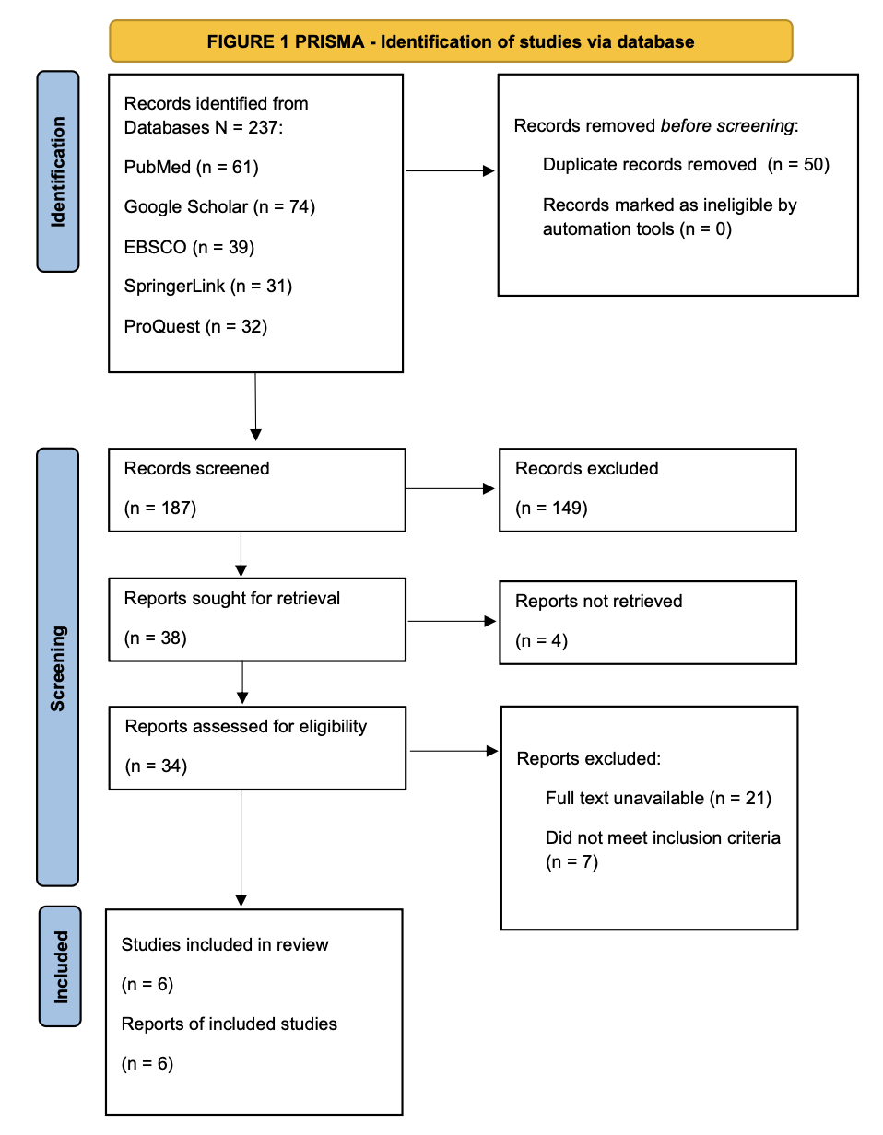

Results
The critical appraisal of the selected research demonstrated high levels of dependability (the literature synthesis process can be found in Tables 2-4 of the supplementary files). The research employed qualitative or mixed method studies, which is necessary approach for exploring the nuanced lived experiences of pregnant black women that quantitative data alone might overlook. All studies met the JBI quality criteria of 85% to 100%. As a result, no studies were excluded. Themes were identified across all included studies, and recurring themes mentioned in two or more articles were synthesized into the final analysis.
The study populations focus on Black pregnant or postpartum women within the United States. Collectively, the research covers an age range of 18 to 45 years, with a total of 135 participants represented across the six articles. All studies were conducted in English. A diagram summarizing the literature synthesis process is presented in Figure 2 and Table 1.

Figure 2: Summary of literature synthesis process

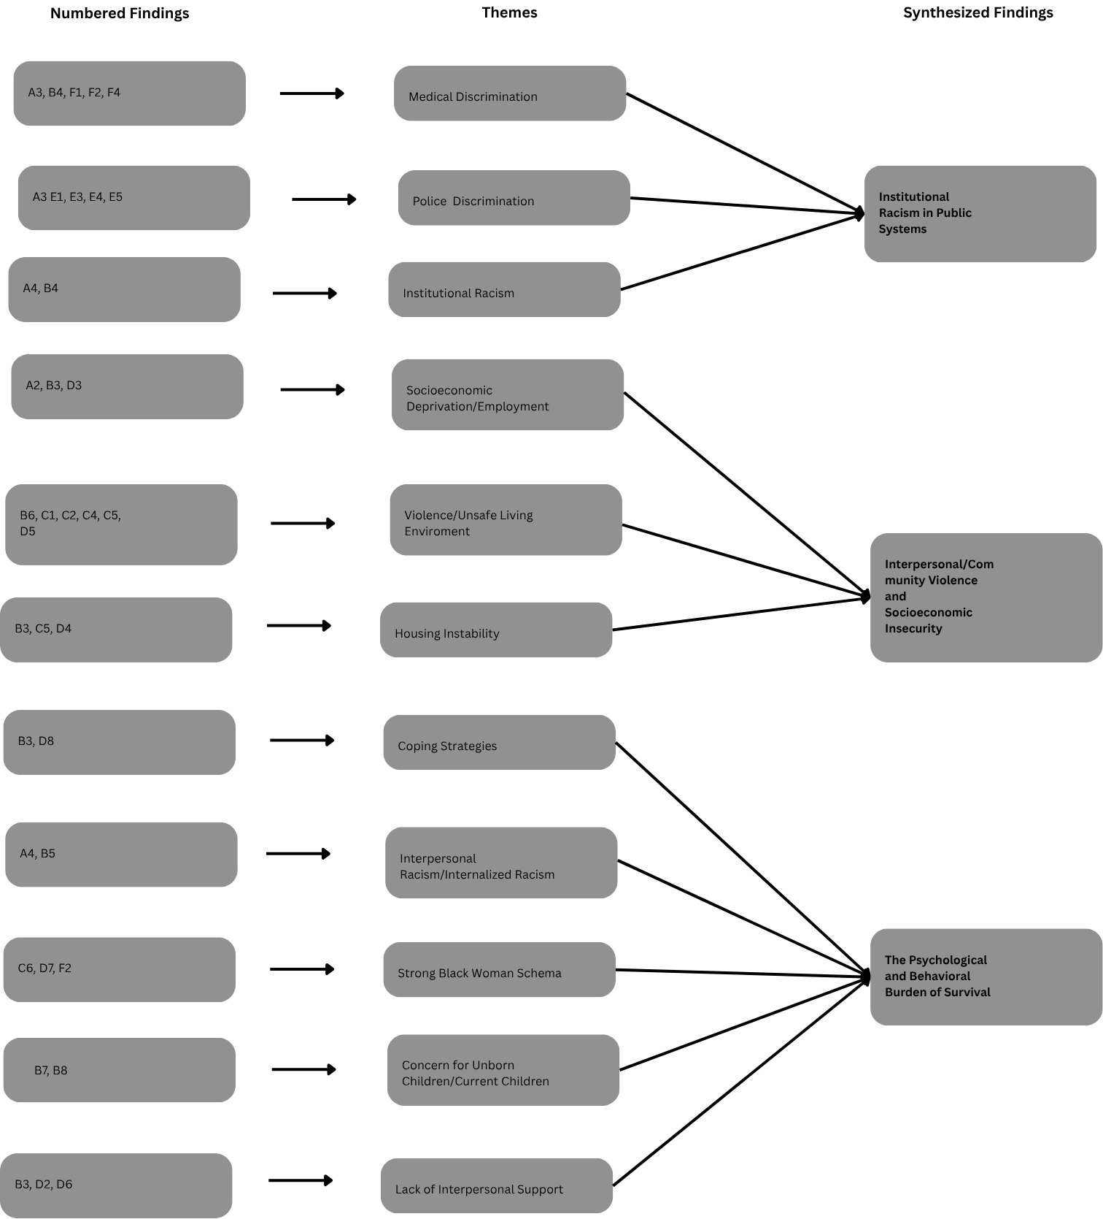
Table 1: Demonstrating overview of studies included in literature synthesis
Author(s) | Aim | Sample Size (N) | Type of Study | Theme | Findings | Implications
Chambers BD, Arabia SE, Arega HA, et al. Exposures to structural racism and racial discrimination among pregnant and early post-partum Black women living in Oakland, California. Stress Health. 2020;36(2):213-219. doi:10.1002/smi.2922 | To describe exposures to structural racism and racial discrimination among pregnant and early postpartum Black women in Oakland and examine the relationship between these factors. | N = 42 Black women; Oakland, CA | Quantitative Cross-sectional study | Exposures to multidimensional chronic stressors including structural and interpersonal racism/discrimination. | Pregnant/postpartum black women who lived in neighborhoods with high race and income extremes experienced racial discrimination in 3 or more situational domains (p= 0.1), the most common being school, getting medical care, on the street, and a store/restaurant. | Black women are exposed to high levels of interpersonal and structural that may have adverse impacts of maternal health outcomes across multiple pregnancies. Local government needs to be held accountable.
Somerville K, Neal-Barnett A, Stadulis R, Manns-James L, Stevens-Robinson D. Hair Cortisol Concentration and Perceived Chronic Stress in Low-Income Urban Pregnant and Postpartum Black Women. J Racial Ethn Health Disparities. 2021;8(2):519-531. doi:10.1007/s40615-020-00809-4 | To assess the relationship between biological stress through hair cortisol concentration and perceived chronic stress among low-income pregnant and postpartum Black women. | N = 24 Low-income Black women; Midwestern USA | Mixed methods cross-sectional study | Biological and perceived chronic stress in urban Black motherhood. | Black women show higher physiological stress than their White counterparts (3-4x higher) which can contribute to poor birth outcomes. In focus group transcripts 4 themes emerged: chronic stress, trauma, racism, and negative thinking. | Providing an open and safe space does not significantly decrease stress levels. Intervention programs must address the biological and environmental roots of stress, including neighborhood safety and cultural coping mechanisms.
Antilla JM, Buckenmeyer AC, DiClemente LM, Carlin M. The Intersection of Intimate Partner Violence, Life Stressors, and Perinatal Loss Among Black Women from the United States: Implications for Enhancing Maternity Care Quality and Public Health Practice. Int J Environ Res Public Health. 2025;22(11):1613. Published 2025 Oct 23. doi:10.3390/ijerph22111613 | Describe the lived experiences of Black women who are survivors of IPV and how additional stressors contributed to perinatal loss and psychological and physical impacts. | N= 22 Black women IPV and perinatal loss; USA | Qualitative (Focus Groups) | Intersectionality of IPV and life stress within adverse maternity outcomes. | Black women experience a persistent psychological stress directly related to IPV, housing instability, unsafe neighborhoods, limited social support and systemic racism that exacerbate mental and physical health outcomes. | Maternity care must integrate early IPV screening to assess risk of perinatal loss, physical/mental adverse effects, and with bereavement support
Koenig MD, Crooks N, Burton T, et al. Structural Violence and Stress Experiences of Young Pregnant Black People. J Racial Ethn Health Disparities. 2024;11(4):1918-1932. doi:10.1007/s40615-023-01661-y | Examine the stress experiences of young Black pregnant women. | N = 11 Young Black women (ages 18-25); Chicago, IL | Qualitative (Interviews) | Utilizing the Health Disparities Research Framework to find the social determinants of health on structural, community, and individual levels. | Young black women are impacted by stress on multiple domains including maintaining housing, employment, safe transportation, and navigating an unsafe community. Unsupportive interpersonal relationships, particularly with their partners, increased stress. | Health care providers need to be aware of the challenges young black pregnant women face to provide more individualized care by addressing SDoH in prenatal visits.
Mehra R, Alspaugh A, Franck LS, et al. "Police shootings, now that seems to be the main issue" - Black pregnant women's anticipation of police brutality towards their children. BMC Public Health. 2022;22(1):146. Published 2022 Jan 20. doi:10.1186/s12889-022-12557-7 | Explore how Black pregnant women perceive police brutality affects them. | N = 24 Black pregnant women; New Haven, CT | Qualitative (Semi-structured Interviews) | Anticipatory stress related to police brutality and how it effects pregnancy and maternal/infant health outcomes. | Even participants who have positive experiences with police anticipate police brutality. Anticipated police brutality toward themselves and their children is a source of stress for black pregnant women. A protective factor is discussing police brutality with their children. | Police brutality must be addressed in all communities to prevent harming the health of birthing people and their children.
Post W, Thomas A, Sutton KM. "Black Women Should Not Die Giving Life": The lived experiences of Black women diagnosed with severe maternal morbidity in the United States. Birth. 2025;52(1):36-45. doi:10.1111/birt.12820 | Understand the lived experiences of Black women diagnosed with severe maternal morbidity (SMM) in communities with high maternal mortality. | N = 12 Black women in high-mortality zip codes; USA | Qualitative (Interviews) | Obstetric racism and medical personnel dismissing concerns effected maternal health outcomes. | Survivors describe being ignored or dismissed by providers and experience long-term PTSD after near-death events. Contemporary forms of racism manifest in the healthcare system through communication failures, differential treatment, stereotyping, and medical errors leading to adverse maternal outcomes. | Combat obstetric racism within healthcare system by prioritizing black patient’s self-reports, especially in emergencies.

Police and Healthcare Discrimination
Four studies explored how institutional racism is a significant factor influencing Black maternal health outcomes across multiple studies. Participants described discrimination across multiple domains, but institutional racism was the most reported form of racism²⁰. Deprived neighborhoods experienced higher rates of medical discrimination and police discrimination²¹. Participants recalled feeling exploited and helpless in their vulnerable state as Black pregnant women, believing that healthcare professionals relied on their authority and institutional power knowing their voices would be trusted over the patients’ concerns. Their intersecting identities influenced how medical professionals perceived, treated, and responded to them throughout their care experiences. Participants recalled judgmental comments made by healthcare professionals such as,
“Well, maybe if you were doing what you were supposed to be doing, she wouldn’t be so little.”²¹
Similarly, many participants felt ignored and dismissed by healthcare providers during serious medical events, resulting in delayed diagnoses, traumatic birth experiences, and distrust in the healthcare system. One participant stated,
“We were not believed. We were not taken seriously.”²²
Participants also described racial stereotyping related to education, income, parenting preparedness, substance use, and pain tolerance, even among highly educated and privately insured women, demonstrating that socioeconomic status did not shield Black women from discriminatory treatment ²². Another study found that fear of police brutality toward their unborn children, particularly sons, was a pervasive source of stress during pregnancy and postpartum²³. Participants expressed feeling powerless to protect their children from systemic racism and violence, with one participant asking,
“How do you protect them or how do you be OK sending them out in the world where they should be safe. And that may or may not be the reality.” ²³
Even women without negative personal experiences with police anticipated harm toward their children and described constantly expecting “that phone call” ²³. These experiences contributed to feelings of vulnerability, mistrust, loss of control, and inability to protect themselves and their unborn children. Collectively, these findings demonstrate how institutional racism within healthcare and policing systems creates chronic stress that may negatively affect Black maternal health outcomes and Allostatic Load.

Interpersonal and Community Violence
Participants described feeling unsafe not only within healthcare and social institutions, but also within their communities and even their own homes. Across the studies, Black women reported living in environments marked by violence, instability, and limited resources, creating chronic stress and emotional exhaustion throughout pregnancy. Many women experienced persistent hypervigilance while living in high-crime neighborhoods, constantly fearing for their own safety and the safety of their children ²⁰. One participant described the emotional burden of community violence:
“You know what I’m saying on one side you hear shootings, like you, never know how to feel when you about to go out.” ²⁰
Participants expressed hopelessness regarding their living conditions and limited opportunities for safety or support, with one woman stating:
“Sometimes I feel like we, we shouldn’t even reproduce.” ²⁰
Additionally, many women did not feel safe within their own homes due to intimate partner violence (IPV) that intensified during pregnancy. Participants described experiencing constant fear, anxiety, depression, PTSD, and isolation, with one participant stating:
“I had constant anxiety during that pregnancy because of the fights and the stress at home. My body never felt safe.” ²⁴
Fear of judgment and stigma also caused some women to avoid prenatal care which limited opportunities for obstetric intervention and increasing stress. One participant explained:
“I didn’t want the doctor to see the bruises and start asking questions, so I just stayed home instead.” ²⁴
Unsafe housing and inadequate healthcare access further intensified vulnerability, as participants described living in dangerous neighborhoods with shootings and police raids while pregnant, lacking nearby hospitals capable of providing emergency obstetric care, and being unable to find employment or safe housing due to pregnancy discrimination²⁵. Collectively, these findings demonstrate that Black women often navigate pregnancy in environments where they feel unprotected and unsafe. Consequently, this situation perpetuates chronic stress and reinforces interpersonal and community violence.

The Psychological Burden of Survival
The Strong Black Woman schema is a significant psychosocial burden among Black pregnant women, demonstrating how expectations of strength, emotional suppression, caregiving, and endurance may have deeper psychological and physiological consequences. Across 5 studies, participants described feeling pressured to remain resilient through abuse, pregnancy complications, grief, racism, and emotional distress while prioritizing the needs of others above their own well-being. Women felt unable to openly discuss intimate partner violence (IPV), pregnancy loss, or emotional suffering because vulnerability was discouraged or ignored within their environments ²⁴. One participant described the silence surrounding abuse and grief, stating:
“It was like nobody wanted to talk about it… not the baby, not what he did to me. It felt like they were saying none of it mattered.”²⁴
Participants frequently internalized the expectation to continue functioning despite trauma, suppressing their own emotions while caring for partners, children, and family responsibilities. This pressure to endure was also reflected within healthcare interactions, where Black women reported that their pain and emotional needs were minimized or dismissed. Racial stereotypes surrounding Black women’s pain tolerance influenced provider behavior and treatment decisions, even during childbirth ²². One participant recalled being denied adequate pain management postpartum, explaining:
“The nurse came in and said, ‘You are not due for [pain] medication for another two hours.’ She made me wait. So, I literally just cried the first entire night in pain.” ²²
Despite severe bleeding and inability to physically move, she was still reprimanded for having her baby in bed with her because she could not get up to care for her infant. These experiences reinforced the expectation that Black women must withstand suffering without complaint while continuing to prioritize caregiving responsibilities over their own recovery and emotional needs. Other participants described emotional numbness and disconnection after traumatic pregnancy and birth experiences, suggesting that chronic stress and repeated invalidation diminished their ability to fully process emotions. Women also described balancing constant caregiving demands while attempting to regulate their stress for the sake of their unborn children, often neglecting their own emotional and physical well-being in the process ²⁵. One participant stated:
“I don’t really feel nothing, but sometimes when I’m stressed and when I’m mad, I try to calm down just because I know it really impact the baby.” ²⁵
Although some women utilized adaptive coping strategies such as church involvement, music, personal care, and physical activity, others described emotional eating, isolation, alcohol/drug use, sexual intercourse, avoidance, or emotional shutdown due to overwhelming stress and lack of support ^{20, 25}. The cumulative burden of racism, caregiving, trauma, emotional suppression, and survival was also reflected physiologically. Low-income Black pregnant women demonstrated hair cortisol concentration (HCC) levels three to four times higher than their White counterparts throughout pregnancy and postpartum, demonstrating the biological embodiment of chronic stress ²⁰. Participants described chronic stress as “a living nightmare” ²⁰ tied to unsafe environments, limited resources, financial instability, and lack of interpersonal support Collectively, these findings demonstrate that the Strong Black Woman schema functions not as a protective identity, but as a survival mechanism that often requires Black women to suppress vulnerability, endure trauma silently, and prioritize others before themselves, ultimately contributing to psychological distress, emotional exhaustion, and increased physiological allostatic load during pregnancy. This study introduces the concept of Collective Allostatic Load 2.0 Among Pregnant Women, which conceptualizes stress accumulation as both an individual and community-level phenomenon shaped by systemic stressors and sociocultural identity, as illustrated in Figure 3.

Figure 3: Conceptual Pathway Model of Allostatic Load 2.0 Among Pregnant Black Women
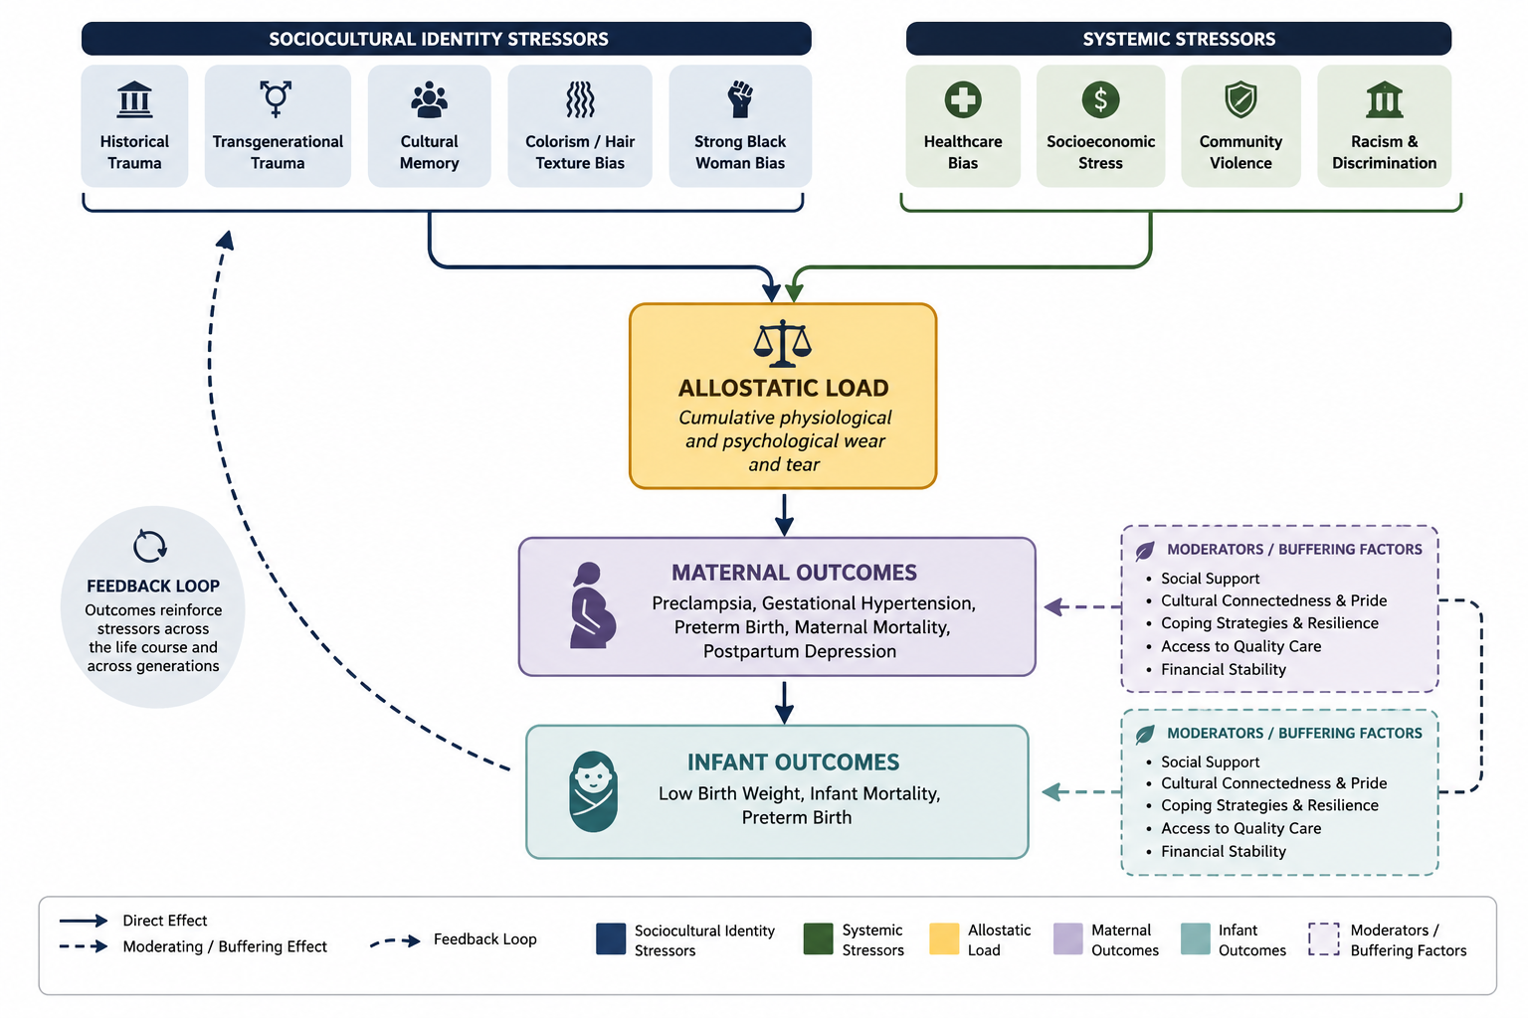

Discussion
The central aim of this literature synthesis was to examine how psychosocial stressors contribute to elevated allostatic load and adverse maternal health outcomes among Black pregnant women in the United States. Studies published between 2020 and 2025 were critically appraised and analyzed, with findings consistently demonstrating that institutional racism, interpersonal and community violence, and the psychological burden associated with survival contribute to chronic stress that increases allostatic load during pregnant and postpartum Black women. While studying allostatic load biomarkers among infertile women undergoing ovarian stimulation, researchers found that higher allostatic load scores were linked to adverse pregnancy outcomes, including increased odds of preeclampsia (62%), preterm birth (44%), and low birth weight (39%)²⁶. These findings are also consistent with international research. For example, studies conducted in the United Kingdom found that minority women were often left uninformed about their pregnancies and care plans due to communication barriers, limited English proficiency, and the effects of a technocratic healthcare system in which patients were treated as tasks rather than individuals²⁷.
There is various evidence demonstrating that racial discrimination and chronic stress negatively affect maternal health outcomes. Black women are placed at increased risk from the very beginning of prenatal care due to systemic inequities embedded within healthcare and social systems. Addressing these disparities requires interventions that are accessible, cost effective, and community centered. Greater investment should be directed toward community resources such as peer support groups and maternal wellness programs that can help reduce the effects of stress during pregnancy. Research also highlights the important role of doula services in addressing birth inequities. Doula support has been associated with lower rates of preterm birth, cesarean delivery, and low birth weight, as well as improved breastfeeding initiation ²⁸⁻²⁹. Continuous communication from doulas throughout pregnancy strengthens maternal self-efficacy and improves coping strategies for stress management ³⁰⁻³¹. Furthermore, incorporating doulas from the same communities as Black mothers may enhance cultural responsiveness of maternal healthcare. Doulas who share lived experiences and similar racial, cultural, or community backgrounds can help foster trust and may be better positioned to advocate for patients and facilitate positive birth experiences. From a practice perspective, hospitals, clinics, and non-profit organizations should prioritize partnerships with community-based doula programs and integrate doulas into interdisciplinary maternal care teams. As maternal mortality rates among Black women continue to rise, it is essential to amplify the voices and experiences of those who are often overlooked within healthcare systems, while recognizing that these experiences may not reflect those of all Black women.

Limitations
This synthesis review has several limitations that should be acknowledged. First, all included studies were published between 2020 and 2025, which limited the historical scope of the review and may not fully capture long-term trends in maternal health disparities affecting Black women. Additionally, access to articles was limited by the availability of full-text resources accessible through student subscriptions, which may have excluded relevant studies that needed institutional or paid access. The review also focused primarily on studies conducted in the United States, where the definition of “Black woman” is restricted to African American populations. As a result, the findings may not reflect the experiences of Black women from other countries, cultures, or ethnic backgrounds within the African diaspora. Furthermore, only English-language studies were included which introduced language bias and excluded valuable international research. Another limitation is the small evidence base, as only six articles met the inclusion criteria, which limited the generalizability of the findings. In addition, a single reviewer completed the screening and data extraction processes, and the absence of dual screening increased the potential for selection bias and human error. The included studies may not fully represent the diversity of Black pregnant women, including variations in socioeconomic status, immigration status, geographic location, cultural background, gender identity, and healthcare experiences.
Despite these limitations, this synthesis review has an important strength. All synthesized articles were evaluated using the JBI critical appraisal tool and were determined to have high dependability, which ensures credibility and the selected studies meet quality standards. Future research should address these limitations by including larger and more diverse study populations, incorporating international perspectives, expanding inclusion to non-English studies, and utilizing multiple reviewers during the screening and data extraction processes to reduce bias. Further studies should also explore the unique experiences of diverse subgroups of Black pregnant women, such as Nigerian women or the LGBTQ community, to provide a comprehensive understanding of maternal health disparities and improve culturally competent healthcare interventions.

Conclusion
Black maternal health disparities are rooted in structural and psychosocial inequities that extend beyond biomedical risk factors alone. Culturally competent maternal healthcare interventions are necessary to reduce chronic stress exposure and improve maternal and infant health outcomes among Black women. Future research should continue exploring the long-term physiological impacts of chronic stress and allostatic load while prioritizing Black women’s lived experiences in the development of maternal health interventions, policies, and advocacy efforts.

Author Biographies
Lucy Efobi
Lucy is a fourth-year undergraduate nursing student completing her studies at Felician University and is passionate about promoting equitable and culturally sensitive care in underserved communities, particularly within the sphere of maternal and community health. Her research interests encompass topics including how social determinants such as racism, stress, food insecurity, and limited prenatal access may contribute to maternal and neonatal outcomes. She is also interested in how targeted education tools can improve prenatal health literacy among pregnant women with regards to recognition of complications like preeclampsia or preterm labor.

Kamilah Marie Woodson, Ph.D.
Dr. Kamilah Marie Woodson is the former, Associate Dean/Director of Graduate Studies, Department Chair “woman”, and Director of Training of the APA Accredited Counseling Psychology Ph.D. program. She is currently a Full Professor with tenure in the Howard University School of Education, Department of Human Development and Psycho-educational Studies, and is conducting research on friendship and its impact on psychological functioning among women of color. To date, Dr. Woodson has published over 25 referred journal articles and book chapters and has served on over 100 Doctoral Dissertation Committees (Advisor-40).

References
- Hoyert DL. Maternal mortality rates in the United States, 2024. NCHS Health E-Stats. 2026 Mar;(113):1-7. National Center for Health Statistics, Centers for Disease Control and Prevention. https://www.cdc.gov/nchs/data/hestat/hestat113.htm
- Manuck TA. Racial and ethnic differences in preterm birth: A complex, multifactorial problem. Semin Perinatol. 2017;41(8):511-518. doi:10.1053/j.semperi.2017.08.010
- Ely DM, Driscoll AK. Infant Mortality in the United States, 2023: Data From the Period Linked Birth/Infant Death File. National Vital Statistics Reports. National Center for Health Statistics; 2025. Published June 12, 2025. https://dx.doi.org/10.15620/cdc/174592
- Ro A, Goldberg RE, Kane JB. Racial and ethnic patterning of low birth weight, normal birth weight, and macrosomia. Prev Med. 2019;118:196-204. doi:10.1016/j.ypmed.2018.10.012
- Braveman P, Dominguez TP, Burke W, et al. Explaining the Black-White Disparity in Preterm Birth: A Consensus Statement From a Multi-Disciplinary Scientific Work Group Convened by the March of Dimes. Front Reprod Health. 2021;3:684207. Published 2021 Sep 2. doi:10.3389/frph.2021.684207
- Howell EA. Reducing Disparities in Severe Maternal Morbidity and Mortality. Clin Obstet Gynecol. 2018;61(2):387-399. doi:10.1097/GRF.0000000000000349
- Morgan N, Christensen K, Skedros G, Kim S, Schliep K. Life stressors, hypertensive disorders of pregnancy, and preterm birth. J Psychosom Obstet Gynaecol. 2022;43(1):42-50. doi:10.1080/0167482X.2020.1778666
- McEwen BS, Stellar E. Stress and the individual: Mechanisms leading to disease. Arch Intern Med. 1993;153(18):2093-2101.
- Geronimus AT. The weathering hypothesis and the health of African-American women and infants. Ethn Dis. 1992;2(3):207-221.
- Braveman P, Heck K, Egerter S, et al. Worry about racial discrimination: A missing piece of the puzzle of Black-White disparities in preterm birth?. PLoS One. 2017;12(10):e0186151. Published 2017 Oct 11. doi:10.1371/journal.pone.0186151
- Avorgbedor F, McCoy TP, Mittal A, Hubbard L, Pickett S. Life stressors, hypertensive disorders of pregnancy, and gestational diabetes by race/ethnicity. PLoS One. 2025;20(4):e0321615. Published 2025 Apr 21. doi:10.1371/journal.pone.0321615
- Dominguez TP, Dunkel-Schetter C, Glynn LM, Hobel C, Sandman CA. Racial differences in birth outcomes: the role of general, pregnancy, and racism stress. Health Psychol. 2008;27(2):194-203. doi:10.1037/0278-6133.27.2.194
- Chambers BD, Fontenot J, McKenzie-Sampson S, et al. "It was just one moment that I felt like I was being judged": Pregnant and postpartum black Women's experiences of personal and group-based racism during the COVID-19 pandemic. Soc Sci Med. 2023;322:115813. doi:10.1016/j.socscimed.2023.115813
- Beauboeuf-Lafontant T. Behind the Mask of the Strong Black Woman: Voice and the Embodiment of a Costly Performance. Temple University Press; 2009. http://www.jstor.org/stable/j.ctt14bs78r
- Woods-Giscombé CL. Superwoman schema: African American women's views on stress, strength, and health. Qual Health Res. 2010;20(5):668-683. doi:10.1177/1049732310361892
- Page MJ, McKenzie JE, Bossuyt PM, et al. The PRISMA 2020 statement: An updated guideline for reporting systematic reviews. BMJ. 2021;372:n71. doi:10.1136/bmj.n71
- Lockwood C, Munn Z, Porritt K. Qualitative research synthesis: methodological guidance for systematic reviewers utilizing meta-aggregation. Int J Evid Based Healthc. 2015;13(3):179-187. doi:10.1097/XEB.0000000000000062
- Moola S, Munn Z, Tufanaru C, et al. Systematic reviews of etiology and risk. In: Aromataris E, Munn Z, eds. Joanna Briggs Institute Reviewer’s Manual. Vol 5. The Joanna Briggs Institute; 2017:217-269.
- Munn Z, Porritt K, Lockwood C, Aromataris E, Pearson A. Establishing confidence in the output of qualitative research synthesis: the ConQual approach. BMC Med Res Methodol. 2014;14:108. Published 2014 Sep 20. doi:10.1186/1471-2288-14-108
- Somerville K, Neal-Barnett A, Stadulis R, Manns-James L, Stevens-Robinson D. Hair Cortisol Concentration and Perceived Chronic Stress in Low-Income Urban Pregnant and Postpartum Black Women. J Racial Ethn Health Disparities. 2021;8(2):519-531. doi:10.1007/s40615-020-00809-4
- Chambers BD, Arabia SE, Arega HA, et al. Exposures to structural racism and racial discrimination among pregnant and early post-partum Black women living in Oakland, California. Stress Health. 2020;36(2):213-219. doi:10.1002/smi.2922
- Post W, Thomas A, Sutton KM. "Black Women Should Not Die Giving Life": The lived experiences of Black women diagnosed with severe maternal morbidity in the United States. Birth. 2025;52(1):36-45. doi:10.1111/birt.12820
- Mehra R, Alspaugh A, Franck LS, et al. "Police shootings, now that seems to be the main issue" - Black pregnant women's anticipation of police brutality towards their children. BMC Public Health. 2022;22(1):146. Published 2022 Jan 20. doi:10.1186/s12889-022-12557-7
- Antilla JM, Buckenmeyer AC, DiClemente LM, Carlin M. The Intersection of Intimate Partner Violence, Life Stressors, and Perinatal Loss Among Black Women from the United States: Implications for Enhancing Maternity Care Quality and Public Health Practice. Int J Environ Res Public Health. 2025;22(11):1613. Published 2025 Oct 23. doi:10.3390/ijerph22111613
- Koenig MD, Crooks N, Burton T, et al. Structural Violence and Stress Experiences of Young Pregnant Black People. J Racial Ethn Health Disparities. 2024;11(4):1918-1932. doi:10.1007/s40615-023-01661-y
- Barrett ES, Vitek W, Mbowe O, et al. Allostatic load, a measure of chronic physiological stress, is associated with pregnancy outcomes, but not fertility, among women with unexplained infertility. Hum Reprod. 2018;33(9):1757-1766. doi:10.1093/humrep/dey261
- MacLellan J, Collins S, Myatt M, Pope C, Knighton W, Rai T. Black, Asian and minority ethnic women's experiences of maternity services in the UK: A qualitative evidence synthesis. J Adv Nurs. 2022;78(7):2175-2190. doi:10.1111/jan.15233
- Thomas MP, Ammann G, Brazier E, Noyes P, Maybank A. Doula Services Within a Healthy Start Program: Increasing Access for an Underserved Population. Matern Child Health J. 2017;21(Suppl 1):59-64. doi:10.1007/s10995-017-2402-0
- Kozhimannil KB, Hardeman RR, Alarid-Escudero F, Vogelsang CA, Blauer-Peterson C, Howell EA. Modeling the Cost-Effectiveness of Doula Care Associated with Reductions in Preterm Birth and Cesarean Delivery. Birth. 2016;43(1):20-27. doi:10.1111/birt.12218
- Gruber KJ, Cupito SH, Dobson CF. Impact of doulas on healthy birth outcomes. J Perinat Educ. 2013;22(1):49-58. doi:10.1891/1058-1243.22.1.49
- Pascali-Bonaro D. Childbirth education and doula care during times of stress, trauma, and grieving. J Perinat Educ. 2003;12(4):1-7. doi:10.1624/105812403X107017

